System Architecture Diagram

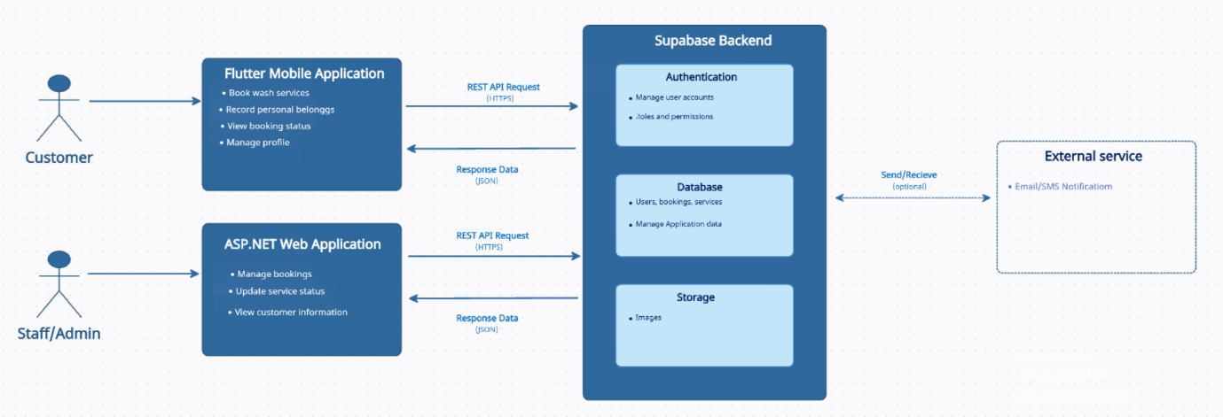

System Architecture Analysis
Who uses the Flutter application?
Customers use the Flutter mobile application to interact with the customer-facing side of the Lifestyle Square Car Wash Management System. Customers can provide their vehicle information, complete the digital vehicle intake process, record personal belongings inside the vehicle, view their vehicle's service status. The Flutter application therefore provides customers with direct access to their vehicle service information without requiring them to repeatedly approach staff for updates.
Who uses the ASP.NET application?
Lifestyle Square staff and administrators use the ASP.NET web application to manage the operational side of the car wash. The web application allows staff to manage vehicle intake, manage the virtual service queue, update vehicle service stages, monitor wash-bay utilisation, manage estimated completion times and manage weekday bookings. Staff authentication is also required before accessing the operational functions of the system.
What is Supabase responsible for?
Supabase acts as the shared backend of the system. It provides the central services that are used by both the Flutter Mobile Application and the ASP.NET Web Application.
The Authentication component is responsible for managing user accounts and controlling access to the system. This supports the requirement that only authorised staff should be able to create, update or manage vehicle service records.
The Database stores and manages the application's information. This includes customer, vehicle, valuables, queue, service and reservation information.
The Storage component shown in the diagram is intended for storing files or images where required.
How does the Flutter application communicate with Supabase?
The Flutter mobile application communicates with Supabase to store and retrieve customer, vehicle, queue and reservation information. When a customer submits or updates information through the mobile application, the information is transferred to the centralised Supabase backend. The Flutter application can also retrieve updated information, such as the current vehicle service status, estimated completion time and reservation information.
This communication allows information entered through the customer application to become available to the rest of the system.
How does the ASP.NET application communicate with Supabase?
The ASP.NET web application communicates with Supabase to retrieve and manage operational information required by Lifestyle Square staff. Through the shared backend, staff can manage vehicle intake records, valuables information, the virtual service queue, service progress, estimated completion times and weekday bookings.
For example, when staff update a vehicle's service stage, the updated status is stored in Supabase. The updated information can then be made available to the Flutter application so that the customer can view the progress of their vehicle. This supports the integration requirement that changes to a vehicle's service status must be reflected in the virtual queue and communicated to customers where applicable.
How do the two applications form one integrated solution?
The Flutter mobile application and ASP.NET web application form one integrated system by using the same centralised Supabase backend. The Flutter application provides the customer-facing functionality, while the ASP.NET application provides the staff-facing operational functionality. Both applications access shared information stored in Supabase rather than maintaining separate sets of vehicle, customer, queue and reservation information.This shared architecture allows the two applications to work together as a single integrated Car Wash Management System.

Link: https://app.creately.com/d/1aK5nNTFgPo/edit

